Algebra 1: Unit 12, Lesson 1

- Jacob wants to collect data on whether his classmates prefer Netflix, Hulu, or YouTube TV.
Is the data Jacob wants to collect categorical or numerical?

categorical

- Leo conducted a survey among the students at his school on their favorite sport. The data he collected is summarized in the frequency table shown.
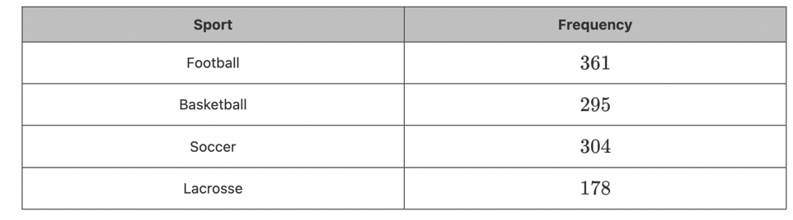
Is the data Leo collected categorical or numerical?

numerical

- Anton wants to create a graphical display that represents the population of Jacksonville, Florida each year for the last ten years. Anton wants his data to be displayed in intervals.
Which graphical display will best represent the data?

Histogram

